# BASIC STATISTICS-2

a) **99% Confidence Interval Using Sample Standard Deviation**

To construct a 99% confidence interval for the mean durability of print-heads, we'll follow these steps:

**STEP 1:** Calculate the sample mean, sample standard deviation and sample size (n)

Sample mean is calculated as ($\overline{μ}):$

$\overline{μ}=\frac{\sum_{i=1}^{n}{x_{i}}}{n}$

Sample standard deviation is calculated as (s):

$$s= \sqrt{\frac{1}{n-1}\sum_{i=1}^{n}{{(x_{i}-\overline{x})}^{2}}}$$

where, $x_{i}$ are individual sample points, ***n*** is the sample size and (***n-1***) is the degree of freedom.

**STEP 2:** Determine the t-value for 99% confidence level

As the sample size is small and population standard deviation is unknown, t-distribution is used as it accounts for the additional variability for small samples when estimating the population standard deviation.

The degree of freedom is 14 here, and the critical t-value is taken from the t-distribution table.

**STEP 3:**  Calculate the Margin of Error (MOE)

The margin of error is calculated as:

$$MOE= t_{critical}×\frac{s}{\sqrt{n}}$$

**STEP 4:** Calculate the Confidence Interval

The 99% Confidence interval for the population mean µ is:

$$(\overline{x}-MOE, \overline{x}+MOE)$$

**Python code:**

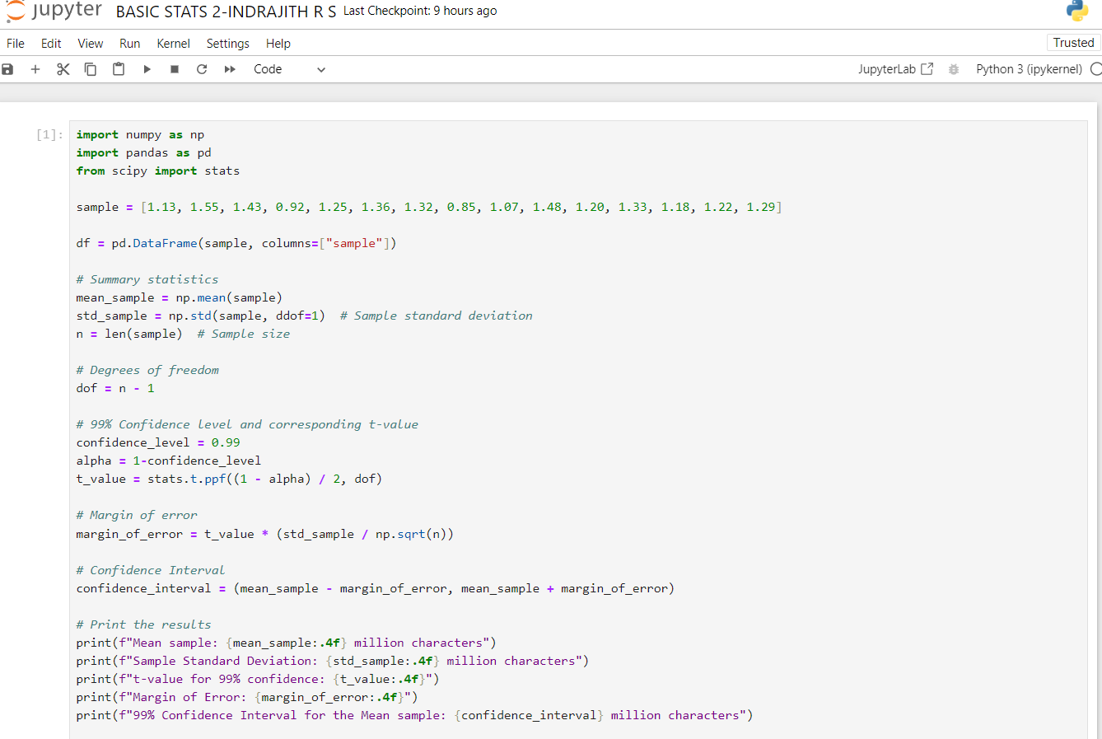

**RESULTS:**

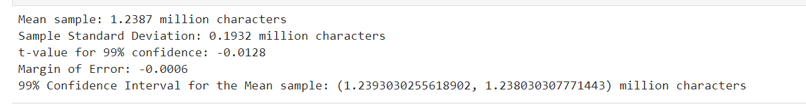

b) **99% Confidence Interval Using Known Population Standard Deviation**

If the population standard deviation is known then z-distribution can be used instead of t-distribution.

**STEP 1**: Calculate the sample mean ($\overline{μ})$

**STEP 2**: Determine the z-value for 99% confidence level

The z-value corresponding to 99% confidence level is approximately $z_{critical}=2.576$

**STEP 3:** Calculate the Margin of Error (MOE)

$$MOE= z_{critical}×\frac{σ}{\sqrt{n}}$$

**STEP 4:** Calculate the Confidence Interval

The 99% Confidence interval for the population mean µ is:

$$(\overline{x}-MOE, \overline{x}+MOE)$$

**Python code:**

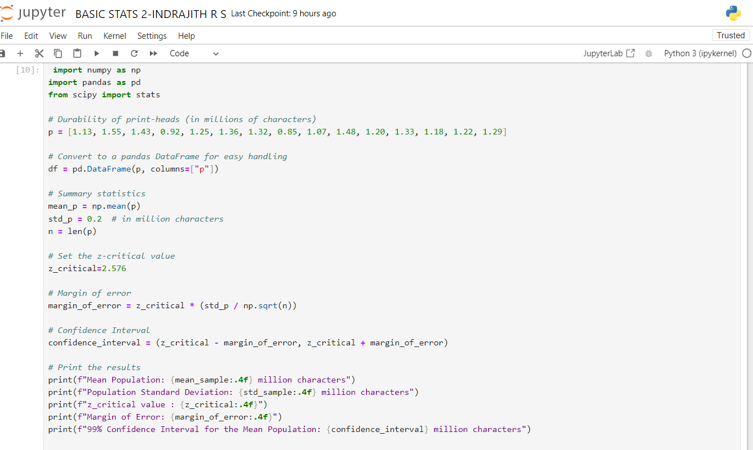

**RESULTS**

